The Urgency of Making Schools Mini Nutrition Service and Fulfillment Units to Accelerate the Implementation of Free Nutritious Meals in Indonesia

K.P.Suharyono S.Hadiningrat¹, Mardiana² , Fitry Taufiq Sahary³, Amrin Soamole^{4,} Sukardi⁵

- Vice Chancellor in Institut Bisnis dan Multimedia (IBM) Asmi Jakarta, Indonesia.
- Chief in in Sekolah Tinggi ManajemenTransportasi (STMT) Malahayati Jakarta, Indonesia.
- Lecturer in Sekolah Tinggi Hukum Hukum Militer (STHM) Jakarta, Indonesia.
- Lecturer in Institut Bisnis dan Multimedia (IBM) Asmi Jakarta, Indonesia.
- Lecturer in Sekolah Tinggi ManajemenTransportasi (STMT) Malahayati Jakarta, Indonesia.

(*) Corresponding Author: harysmwt@gmail.com

Abstract
Efforts to achieve Indonesia's national goals require the state to ensure adequate nutrition for the population through the Free Nutritious Meals (MBG) program launched by President Prabowo Subianto on January 6, 2025, with a target of 28.9 million beneficiaries. The challenge is not easy, given Indonesia's vast territory and ongoing connectivity issues between islands, making it urgent to establish schools as Mini SPPGs. This research design is qualitative with a descriptive explanatory approach to identify and describe research variables narratively and thematically, using standard Indonesian language. The data obtained were categorized into those related to the current SPPG or SPPG Maxi and schools as Mini SPPGs, then narrated according to the research framework and objectives. The qualitative analysis concluded that it is very important and urgent for the Indonesian government to establish schools as Mini SPPGs to accelerate the provision and delivery of nutrition services to the community (students) across all regions of Indonesia, in addition to the existing SPPG (Maxi) system. Supporting factors include the availability of school infrastructure and school committees across all regions of Indonesia. The number of beneficiaries is relatively small, limited to a single school, and collaboration among the pentha helix is needed to strengthen the initiative.
Key words : Astacita, Free Nutritious Meals, SPPG Mini School
INTRODUCTION
The national objectives of the Indonesian people as stated in the preamble to the 1945 Constitution include the need to educate the nation and promote general welfare, which requires the state to be present to achieve these goals through various pro-people, holistic, comprehensive, integral, inclusive, and sustainable programs involving all elements of the nation. Since January 6, 2025, President Prabowo Subianto has launched the Free Nutritious Meals (MBG) program as one of the quick wins of Astacita to ensure adequate nutrition for the community so that they can lead healthy lives while improving their health, education, and welfare. The MGB program is one of the quick wins of the fourth pillar of Astacita, which is “Strengthening human resource development, science, technology, education, health, sports achievements, gender equality, and the empowerment of women, youth, and persons with disabilities” (www.kemenkopmk.go.id on November 11, 2024.
Nutrition remains a critical national issue, with many children in Indonesia still suffering from malnutrition, including stunting, wasting, and micronutrient deficiencies. According to the results of the 2024 Indonesian Nutrition Status Survey (SSGI), the prevalence of stunting/short stature reached 19.8 percent, wasting/underweight based on height reached 7.7 percent, and underweight/low body weight based on age reached 17.1 percent. These conditions have negative impacts on children's physical growth and cognitive development, thereby affecting their quality of life.
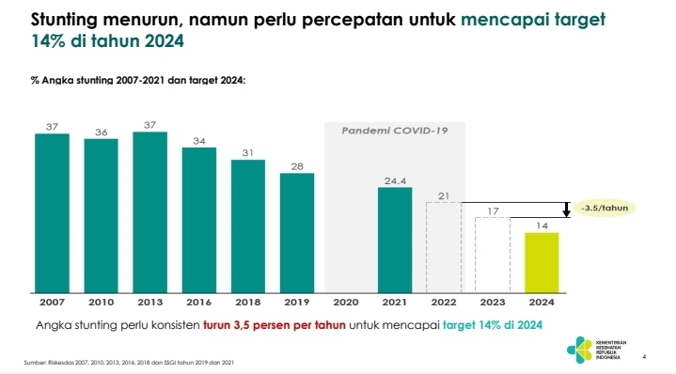

Graph 01: Prevalence of Stunting in Indonesia, 2007-2024
Furthermore, the Ministry of Women's Empowerment and Child Protection noted that nearly 70 percent of school children do not eat breakfast before leaving for school because their parents do not have the financial means to provide breakfast, as their economic situation is weak. Based on a study conducted by the Ministry of PPPA in collaboration with Wahana Visi Indonesia from December 2023 to June 2024 involving 6,909 children across 34 provinces, it was found that 44% of children did not eat dinner due to the lack of food, 32% did not have breakfast before school, and 18% had experienced hunger due to running out of food at home. This data indicates that many Indonesian children face serious nutritional challenges. (www.kemenpppa.go.id on January 19, 2025).
In this regard, the government must be present to find quick and appropriate solutions, including through nutritional intervention for the community through the MBG program. Although lagging behind other countries such as the United States, Finland, Germany, France, Japan, Brazil, India, and others, the administration of President Prabowo Subianto is committed to achieving this goal, with the 2025 state budget allocating Rp70 trillion for the MBG program.
Implementation in other countries can serve as valuable lessons learned, as the positive impacts and benefits of the free school lunch program for students in their respective countries are significant, including making them healthier in their daily activities, more diligent in attending and learning at school, and improving academic performance, thereby becoming the primary foundation for high-quality human resources in the future.
Free lunches have been provided by various countries for decades, even centuries, such as in the United States, Brazil, Finland, India, and Japan. The results show that well-planned and high-quality lunch programs not only improve students' physical well-being but also contribute to improved academic performance. Tikkanen and Urho (2019) in their research emphasize that good nutrition intake has a direct correlation with students' learning abilities. In Finland, it is not only about providing nutritious food but also educating students about healthy eating habits, table manners, and the importance of environmental sustainability.
In Japan, school lunch programs are called “kyushoku” and are not merely about providing food but also integrating it into the educational curriculum regarding nutritional values, hygiene, cooperation, gratitude, and character. (Tanaka and Miyoshi, 2021). School lunches for students in Japan and France also serve as a bio-political and gastro-political arena, promoting improved nutrition, health, food safety quality, and national culinary traditions. (Moffat and Gendron (Eds) 2018 in Hadiningrat and Yuwono, 2025a). In Finland, France, Germany, and the United States, there are already laws regarding free meals, providing legal certainty and sustainability.
In Brazil, free school lunches are known as the “Programa Nacional de Alimentação Escolar” (PNAE), which began in 1955 as a national, holistic program requiring that at least 30% of food ingredients be purchased from local farmers. This strategy has successfully reduced dropout rates, improved academic performance, and simultaneously supported the local economy while serving as a catalyst for broader socio-economic development. (Sidaner et al., 2023). It is also part of broader efforts to address malnutrition and improve student quality in schools (Pedraza et al., 2018). The Lunch Program not only provides food but also helps improve education and reduce social inequality. (Kitaoka, 2018)
In India, free school lunches are known as the “Mid-Day Meal Scheme” (MDMS), which was first launched in 1995. In addition to providing meals, it also improves student attendance and academic performance (Sahai, 2014).
In her thesis, Hilery (2025), who was supervised by one of the authors of this article, found that free lunch programs in Finland, Brazil, Japan, and India had both advantages and disadvantages in their implementation; although their objectives were generally the same, their regulations, policies, and implementations differed. Collaboration is needed from all parties, particularly from the central to local governments, community participation, budgetary support, and sustainability. Furthermore, Hadiningrat et al. (2025) in their book Free Nutritious Meals, Acceleration Program Towards Indonesia's Golden Generation explain that to ensure the sustainability of the free nutritious meal program in Indonesia, a national nutrition law is needed, which includes provisions on free nutritious meals, so that whoever the president is, this MBG program will continue to be implemented. To ensure that beneficiaries residing in the area receive adequate nutrition services and sufficiency, the presence of schools as Mini Nutrition Service and Fulfilment Units (SPPG) is required to support the existing Maxi SPPG under the supervision of the National Nutrition Agency of the Republic of Indonesia.
Schools are the foremost educational institutions that provide education for students from early childhood education/kindergarten, elementary school/equivalent, junior high school/equivalent, and senior high school/equivalent, both public schools managed by the government under the supervision of the Ministry of Basic and Secondary Education of the Republic of Indonesia, the Ministry of Religious Affairs of the Republic of Indonesia, and private schools. Their presence spans the entire territory of the Republic of Indonesia, except in 3T areas (Frontier, Outer, and Backward regions). Schools as Mini SPPGs, with MBG management systems and institutional, organizational, or other activities, fundamentally apply management principles. According to George Terry (Soamole & Hadiningrat, 2025), management has four functions: Planning, Organizing, Actuating, and Controlling, or POAC for short. In relation to schools as mini SPPGs, school principals, teachers, school committees, and stakeholders in the village must understand this properly to ensure that service delivery and nutritional fulfillment for students align with the targets set by the National Nutrition Agency (BGN). Furthermore, it is explained that the implementation of management functions must be integrated with the six elements of management outcomes, which include man, money, material, method, machine, and market, so that the achievement of objectives will be more effective and efficient, based on outputs and outcomes/benefits.
With this background, data showing the gap between the current situation and the desired situation, as well as benchmarks from the experiences of other countries, the following issues can be formulated:
1.1 What is the urgency of making schools throughout Indonesia into mini SPPGs, in addition to the existing SPPGs?
1.2 What factors support the transformation of schools across Indonesia into mini SPPGs, in addition to the existing SPPGs?
1.3 What recommendations are feasible for the government and other stakeholders to implement in order to transform schools across Indonesia into mini SPPGs, in addition to the existing SPPGs?
The purpose of this study is to identify and describe the urgency of schools throughout Indonesia becoming SPPG Mini, in addition to the existing SPPG (Maxi), in order to accelerate the provision of free nutritious meals to beneficiaries throughout the Republic of Indonesia.

LITERATURE REVIEW
Efforts to educate the Indonesian people, as stated in the Preamble to the 1945 Constitution, must be carried out comprehensively, holistically, and integrally, including through the Free Nutritious Meals program, so that beneficiaries have their nutritional needs met and are healthy enough to carry out their daily activities, including learning at school. (www,bgn.go,id).
Hadiningrat et al. (2025) explain that free lunch programs in some countries are intended to improve nutritional adequacy for students so they can stay healthy in their daily lives, especially in school. Student absenteeism in schools has decreased drastically, and learning motivation has increased, which can improve the quality and achievements of learning. The challenges in implementing free school lunch programs in some countries include government policy factors and the relatively large financial support required, especially given the program's broad scope for the entire population. For Indonesia, it would be beneficial to learn from the success stories of free school lunch programs in other countries to consider when implementing the Free Nutritious Meal Program (MBG).
Furthermore, according to Pratiwi & Sudiarti (2019), the school lunch program is designed to provide quality nutritious food for students during school hours, with a primary focus on meeting nutritional needs, supporting physical growth, and optimizing children's cognitive development.
The World Food Programme (2020) states that the objectives of the healthy eating program are to improve students' health and physical fitness, reduce dropout rates and absenteeism, increase parental involvement in children's education, reduce malnutrition and stunting rates, support the teaching and learning process, and reduce socio-economic disparities. The healthy eating program will provide health benefits such as: sustained improvement in nutritional status, enhanced immune system, and optimized physical and mental growth. It will also provide educational benefits such as: improved concentration and learning ability, reduced absenteeism, and accelerated cognitive development. Additionally, it will provide socio-economic benefits such as: concrete support for low-income families, reduced household economic burden, and strategic investment in human resources.
In their research, Cohen, A. B., et al. (2021) found that free meal programs in the United States and Europe can improve students' academic performance and provide food security for students from low-income families. Pellegrini, A., & Gerber, M. (2021) found that the impact of free meals in developed countries can improve students' health and nutritional status, as well as reduce the social stigma faced by students from low-income backgrounds. Zuercher, A. R., et al. (2022) noted that the provision of free meals during the COVID-19 pandemic in California included challenges in food distribution in remote areas and positive impacts on student participation in learning. Cummings, J., et al. (2022) studied the implementation of free meals in developing countries during the pandemic, where the greatest challenges included distribution and effective resource management. Ahmed, R. (2020) conducted a global study on how free meal programs help address child food insecurity in various countries, and discussed the financial constraints faced by low-income countries in implementing these programs.
Table 01: Comparison of Research Results on Free Lunch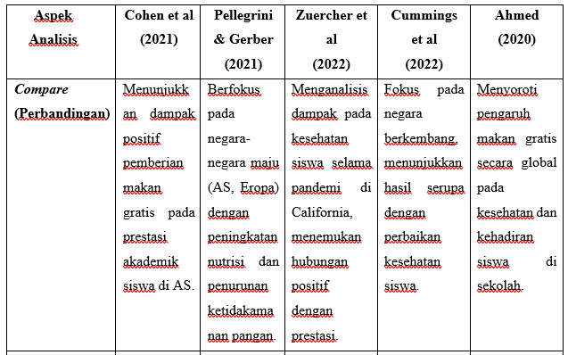
Sumber : Kompilasi penulis, 2025

METHODS
The design of this study is qualitative with an exploratory descriptive approach to discover and describe the phenomenon of the research variable of schools becoming SPPG Mini in order to accelerate the implementation of MBG throughout Indonesia. Data collection techniques include a literature review of credible journal publications, supplemented by interviews with SPPG managers, school principals, observations at SPPG sites, and documentation. The collected data are categorized based on themes/sub-themes and analyzed using thematic narrative techniques (Hadiningrat et al., 2025b). Thematic Narrative Analysis is a qualitative research analysis technique that presents and analyzes data based on data grouped into similar or related themes/sub-themes, then interprets them according to the research problem and objectives into sentences using standard and correct language, ensuring that the interpretation of variables is unbiased and meets scientific standards.
The steps in Thematic Narrative Analysis begin with the researcher developing interview, observation, and documentation guidelines that include variables and indicators. The research subjects are randomly selected as informants who can represent the population according to school level, both in the Ministry of Education and Culture of the Republic of Indonesia (Kemendikdasmen R.I.) and the Ministry of Religious Affairs of the Republic of Indonesia (Kemenag R.I.). The collected data is then categorized according to themes and sub-themes, and described in narrative sentences following standard Indonesian language rules. Data is presented in a specific format, analyzed based on the research questions and objectives, and concluded with concise sentences as answers to the research questions and objectives. Recommendations are then formulated as implications of the research findings.

RESULT AND DISCUSSION
Implementation of MBG by SPPG
The Free Nutritious Meals program launched by President Prabowo Subianto on January 6, 2025, is implemented by the Nutrition Service and Fulfillment Unit (SPPG) as the leading technical implementation unit of the National Nutrition Agency (BGN). By May 2025, the Free Nutritious Meal Program (MBG) had reached 4.8 million beneficiaries through 1,397 Nutrition Service and Fulfilment Units (SPPG) spread across 38 provinces throughout Indonesia. The budget allocated for this program is Rp171 trillion, with Rp2.3 trillion already disbursed as of April 29, 2025. The target to be achieved by the end of 2025 is 28.9 million beneficiaries. (www.indonesia.id, May 7, 2025). Furthermore, Prof. Dadan Hindayana, Head of BGN, explained that the success of the MBG program depends on three main factors: adequate funding, professional and integrity-driven human resources, and sufficient infrastructure reaching all villages across the country.
On the other hand, the current situation, as outlined in the following table: ini :
Table 02: Prevalence of Stunting, Wasting, Obesity, and Anemia in Indonesia, 2018–2021.

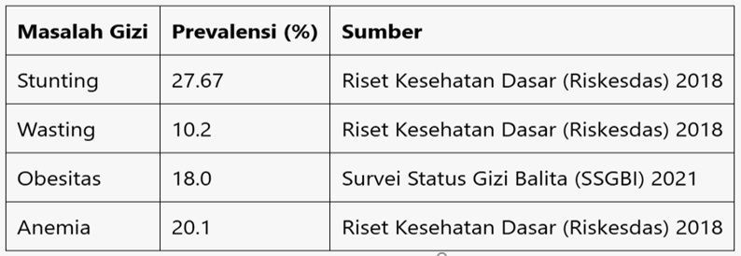
Source: Ministry of Health of the Republic of Indonesia. (2021). 2021 Toddler Nutrition Status Survey (SSGBI).
Poor nutrition in school-aged children can have long-term effects on their health, development, and academic performance. Therefore, the government must intervene in issues related to nutrition, health, and education by ensuring adequate nutrition for the community.
- Long-Term Investment in Human Resources
Improving nutrition from an early age contributes to increased intelligence, learning ability, and long-term health. These high-quality human resources will be the driving force behind national development, in line with the Indonesia Emas 2045 vision.
- Sustainable Economy and Global Competitiveness
A generation free from stunting is expected to be able to compete globally and support a knowledge-based economy, which is part of the pillars of Indonesia Emas.
In the context of this study, the current SPPG organized by BGN and its partners can be referred to as SPPG Maxi because it has a large coverage of 3,000-3,500 beneficiaries, while schools are referred to as SPPG Mini because their coverage is limited to the school itself with beneficiaries consisting of students studying at the school.
The implementation of MBG by BGN is carried out through partnerships with the community and entrepreneurs who are members of a foundation, thereby opening up the widest possible opportunities for community participation. The partnership between BGN and the foundation is a form of triple helix collaboration between the government and the community, supported by other stakeholders such as academics, industry, and the media.
From interviews, observations, and documentation at one of the SPPGs in the Bogor City area, West Java, data was obtained showing that each SPPG prepares nutritious meals for 3,000-3,500 beneficiaries, including PAUD/TK, SD, SMP, SMA/SMK students, non-PAUD toddlers, pregnant women, and nursing mothers.
The SPPG is led by a Head of SPPG, assisted by a Nutritionist and an Accountant, both of whom hold a minimum of a bachelor's degree and are professionals in their respective fields, sourced from the Indonesian Development Mobilization Scholars (SPPI). These three positions are directly recruited by BGN. The remaining 47 support staff, including food handlers (cooks, assistants), general affairs, logistics, distribution, drivers/assistant drivers, safety/security, cleaning, and others, are prepared by the Foundation as a partner of BGN.
The main activities in the SPPG kitchen every day are as follows: starting at 4:00 AM, preparing food ingredients according to the menu list prepared by the Nutritionist, cooking them properly, then portioning them into stainless steel containers (standard ompreng) under the supervision of the Nutritionist, and storing food samples in a food refrigerator/freezer for six days. The meals in the containers are then loaded into a specially designed box truck, and the driver/assistant distributes them to schools and health posts according to the list prepared by the Logistics & Distribution Department. The meals are received by the school principal or designated teacher. The meals are then served at each school with the assistance of the respective teachers. In the afternoon, the driver/assistant visits the schools to collect the containers and bring them back to SPPG for inspection and recording of any leftover food. If there are leftovers, they are disposed of in designated areas and separated according to type. The recorded leftover food is then discussed together by the Nutritionist and SPPG Management for evaluation and follow-up with the school. For example, in the form of educational sessions on the importance of nutrition and the habit of finishing meals. This main activity will be repeated daily throughout the school days.

Berikut ini disajikan gambar kegiatan di SPPG Tanah Sereal dan Penerima manfaat MBG di Kota Bogor tanggal 10 Februari 2025 :

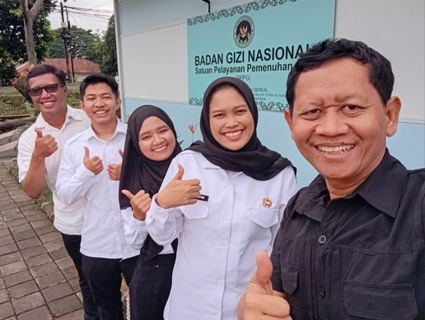 |  | 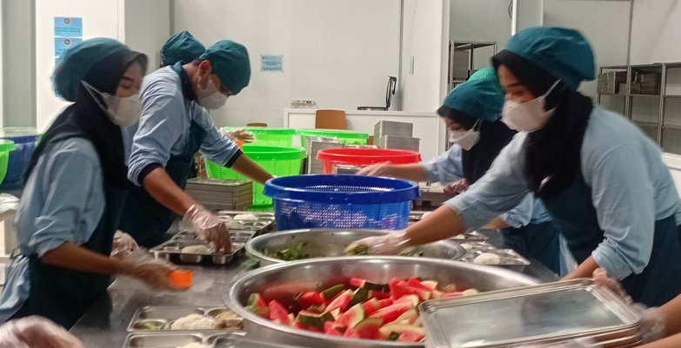
Author & Head of SPPG Tansel |  | Busy in the SPPG Tansel Kitchen
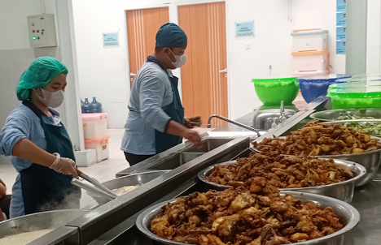 |  | 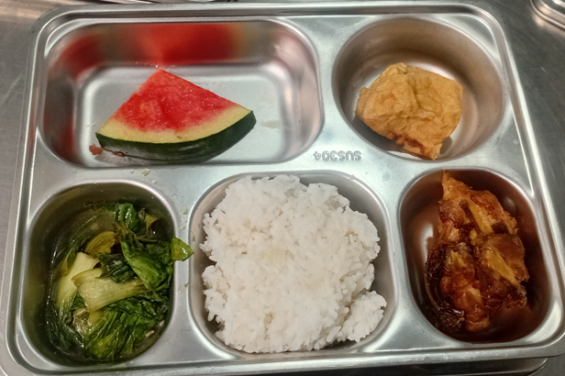
Busy kitchen at SPPG Tansel |  | Meal portions, February 10, 2025
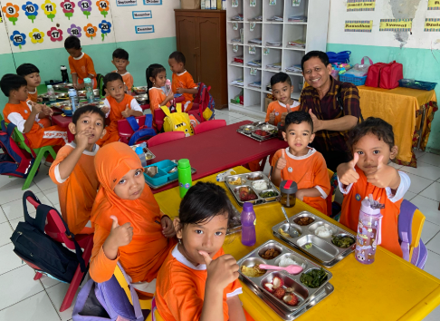 |  | 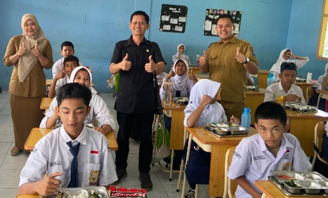
Implementation of MBG at PGRI Munggarana Kindergarten, Bogor City |  | Implementation of MBG At Siliwangi Junior High School, Bogor City
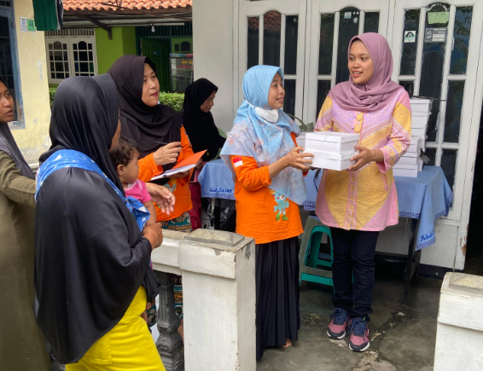 |  | 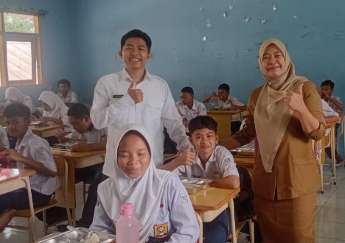
Implementation of MBG for Pregnant Women, Breastfeeding Mothers, and Toddlers Not Enrolled in Early Childhood Education |  | Implementation of MBG At Siliwangi Junior High School, Bogor City

The SPPG Bintang in Cikupa, Tangerang Regency, jointly managed by Dr. Ubaidillah, the La Tanza Sejahtera Foundation/YLTS (Ujang Abdul Liman, et al.), and the Tangerang BGN, is preparing for operations with a coverage of 3,000–3,500 beneficiaries. Below are photos of the training activities conducted on June 14, 2025, by Dr. Ubaidillah, KP. Suharyono S. Hadiningrat, Ujang Abdul Liman, Rusmawardah, and Dewi Zairina.

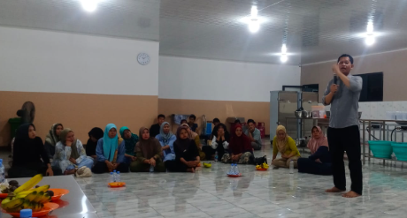 |  | 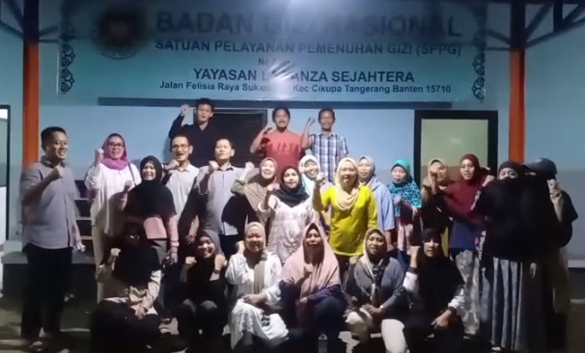
The atmosphere of the technical training for employees |  | Chants to build team solidarity
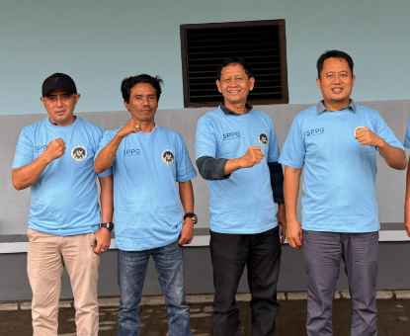 |  | 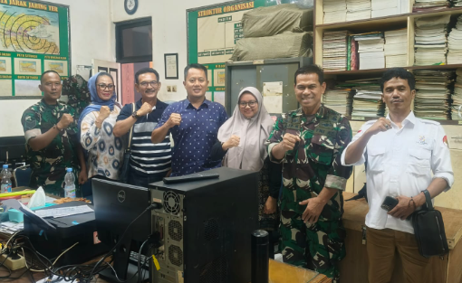
YLTS LTS Management & Partners |  | Territorial Coordination: YLTS, Mita,  Head of SPPG, with Tangerang Military District Commander

In providing nutrition services, SPPG distributes food in accordance with nutritional standards calculated based on the nutritional adequacy of each target group, referring to Indonesian Minister of Health Regulation No. 28 of 2019 concerning Recommended Nutritional Adequacy for the Indonesian People.

Nutritional Standards for Toddlers and Preschool/Kindergarten Children
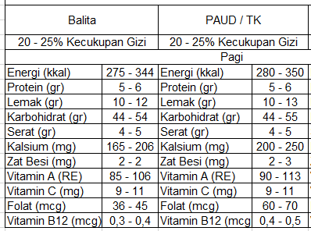

Nutritional Standards for Elementary School Students in Grades 1-3 and 4-6
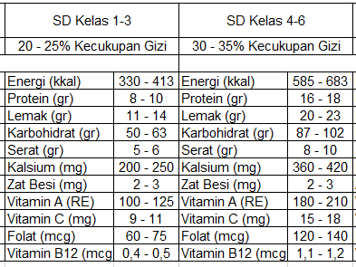

Nutritional Standards for Junior High and High School Students
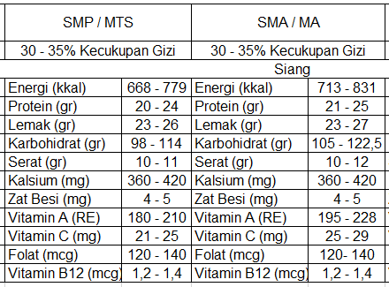

Nutritional Standards for Pregnant Women and Breastfeeding Mothers

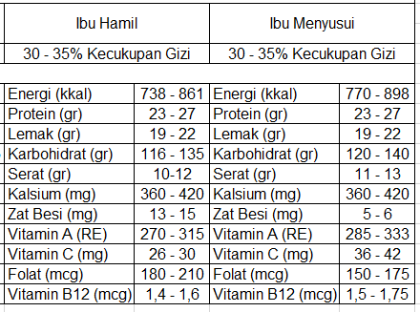

Benchmarks from several countries, along with pictures of the free lunch atmosphere:

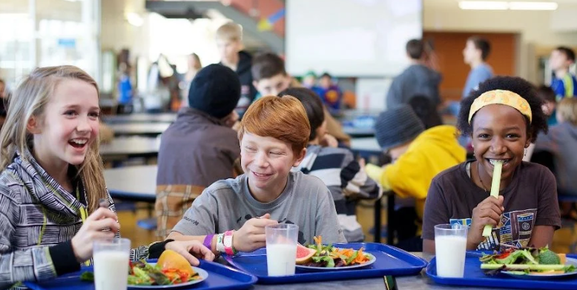 |  | 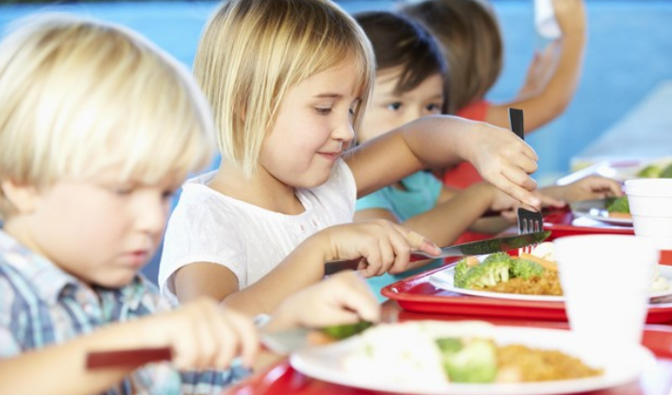
The Atmosphere of Free Lunch in Finland |  | The Atmosphere of Free Lunch in the USA
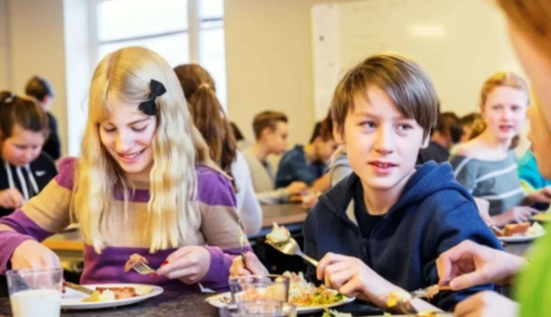 |  | 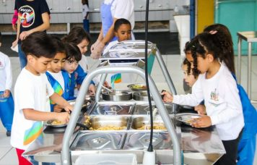
The Atmosphere of Free Lunch in Sweden |  | The Atmosphere of Free Lunch in Brazil
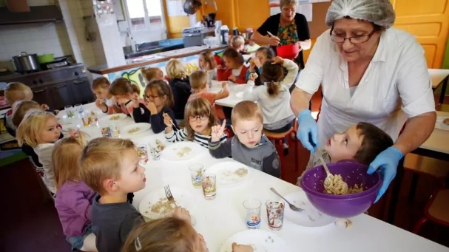 |  | 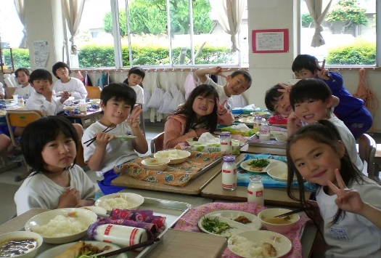
The Atmosphere of Free Lunch in France |  | The Atmosphere of Free Lunch in Japan
.. 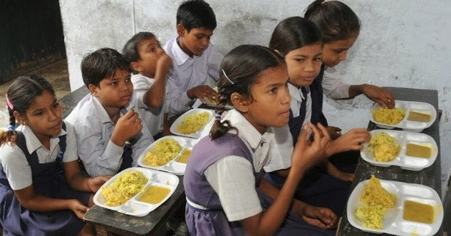 |  | 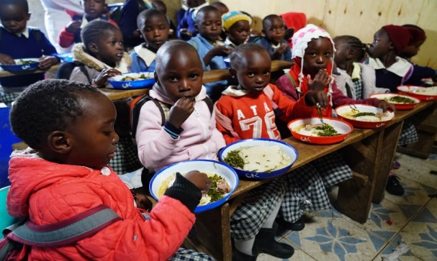
The Atmosphere of Free Lunch in India |  | The Atmosphere of Free Lunch in Kenya
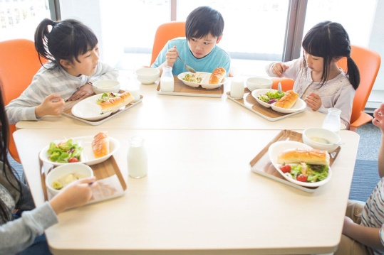 |  | 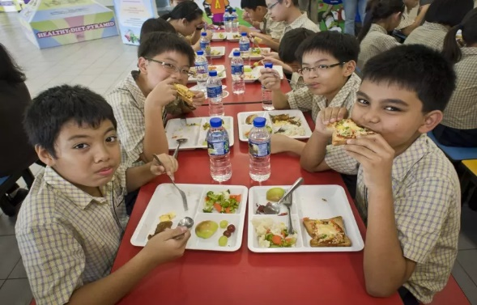
The Atmosphere of Free Lunch in South Korea |  | The Atmosphere of Free Lunch in Singapore

- The Urgency of Making Schools into Mini SPPGs
The vast territory of the Republic of Indonesia stretches from Sabang to Merauke, from Miangas Island to Rotte Island, covering approximately 1,919,440 km² comprising 17,508 islands, 38 provinces, 416 regencies, 98 cities, 7,277 districts, and 83,763 villages/sub-districts (BPS, February 14, 2025), presents a unique challenge requiring innovative solutions. In relation to MBG, Indonesia's geographical location as an archipelagic nation also presents its own challenges. This is where the urgency lies in establishing schools as Mini SPPGs to ensure equitable service delivery and nutritional fulfillment for the community, particularly students. The number of schools across Indonesia is spread throughout the entire nation.
Dapodikdasemen (2024) states that the number of schools across the entire territory of the Republic of Indonesia is 83,376 early childhood education centers (with 2.44 million students), 96,486 kindergartens (with 3.73 million students), 149,804 elementary schools (with 24.04 million students), 43,825 junior high schools (SMP) with 9.97 million students, 14,951 senior high schools (SMA) with 5.32 million students, and 14,491 vocational high schools (SMK) with 5.08 million students. Additionally, data from the Ministry of Religious Affairs (Kemenag) of the Republic of Indonesia (2024) shows that there are Radhatul Athfal/RA at 31,260, Madrasah Ibtidaiyah/MI at 26,809, Madrasah Tsanawiyah/MTs at 19,443, and Madrasah Aliyah/MA at 10,156, and pesantren at 36,000 students.
According to Law No. 20 of 2003 on the National Education System, schools are formal educational institutions that provide primary and secondary education. Schools are also part of the national education system aimed at developing the potential of students to become individuals who are faithful and devout to the One and Only God, possess noble character, are healthy, knowledgeable, skilled, creative, independent, and become democratic and responsible citizens.
Within it, character education is also developed, emphasizing the formation of noble character, and it is an integral part of the national education objectives and implicit in the definition of education as outlined in the aforementioned law.
Then, Government Regulation (PP) No. 57 of 2021 concerning National Education Standards, which has been amended by PP No. 4 of 2022, regulates various aspects of education standards, including content standards, process, graduate competencies, educational personnel, facilities and infrastructure, management, financing, and educational assessment, all of which are closely related to school administration, including the School/Madrasah Committee, which is an independent institution consisting of parents/guardians of students, the school community, and community leaders who care about education.
In the management of education at schools, the School Committee, which consists of teacher representatives, parents of students, and community leaders, also plays a significant role. Its role is particularly crucial in remote areas, such as those in the 3T regions (Frontier, Outer, and Underdeveloped); thus, the presence of schools and school committees is highly necessary. This situation makes it possible to establish Mini SPPGs in schools across Indonesia, in addition to existing SPPGs, thereby achieving rapid, effective, and efficient outreach, equitable service delivery, and nutritional needs fulfillment for beneficiaries.

2.1 School Regulations as Mini SPPG
Regulations need to be made in collaboration with BGN, the Ministry of Primary and Secondary Education, the Ministry of Religious Affairs, the Ministry of Home Affairs, the Ministry of Villages and Transmigration, and the Ministry of Finance of the Republic of Indonesia. Then, technical regulations regarding the implementation of schools as Mini SPPG need to be drafted.

2.2 Institutional Framework of Schools as Mini SPPGs
The institutional framework of schools as Mini SPPGs will collaborate with School Committees and Village Government Institutions to ensure more effective and efficient implementation, without burdening schools due to their new role as Mini SPPGs. Training and MBG funding from the BGN will be directly provided to schools as Mini SPPGs to ensure faster implementation and reduce bureaucratic red tape. In its operations, it will be monitored and mentored by the nearest SPPG (Maxi).
2.3 School Human Resources as Mini SPPG
Human resources (HR) in schools are qualified as teachers so that they can become agents in promoting literacy and education on various topics, including free nutritious meals. They require supportive training in addition to their primary duties as teachers or school principals. Additionally, there is a School Committee composed of teachers, parents, and community leaders, who can also serve as human resources capable of organizing a Mini SPPG with adequate training. Furthermore, collaboration can also be established with the Village Government, Village Community Institutions, BumDes, the Red and White Cooperative, and PKK mothers. In its implementation, mentoring is needed from the SPPG Management Team (Maxi) closest to the schools.

2.4 School Budget as a Mini SPPG
The MBG budget from the state budget is managed by BGN in the implementation of Schools as Mini SPPGs, so the mechanism is regulated by a direct budget from BGN to schools with state financial accountability in accordance with applicable laws and regulations. In this regard, school principals already understand how to manage state finances, as they have experience in managing BOS (School Operational Assistance) funds from the government.
1. Factors supporting the establishment of schools as mini SPPGs
The existence of schools, almost all of which are located in villages throughout Indonesia, is one of the factors supporting the establishment of schools as mini SPPGs. In addition, there are also:
a.School infrastructure already exists throughout Indonesia, except in 3T areas where it is still limited.
b.The location of schools within residential areas where students and their parents reside, spread across the entire territory of the Republic of Indonesia.
c.The scope of services and nutritional support is more accessible as schools serve as the frontline in providing education for students and the community. (Exceptions apply for 3T areas or remote, frontier, and underdeveloped regions).
d.The number of beneficiaries is relatively small, as it only serves a limited number of students at the school, as well as non-PAUD children, pregnant women, and breastfeeding mothers in the vicinity of the school.
e.Utilization of local food sources adapted to local culture.
f.Schools have well-educated human resources, especially school principals and teachers, which facilitates the implementation of the Mini SPPG program.
g.Schools have a School Committee consisting of teachers, parents, and community leaders, which facilitates coordination and collaboration in implementing the Mini SPPG program.
h.There is collaboration across ministries/agencies from the central government down to the provincial, district/city, sub-district, and village/neighborhood levels.Disamping itu, juga ada tantangan-tantangan yang perlu mendapat solusi terbaik agar pelaksanaan menjadi Sekolah sebagai SPPG Mini can be realized immediately, including: a) MBG budget constraints; b) limited understanding of nutrition among teachers and school committees; c) old and damaged school infrastructure; d) limited availability of food ingredients; d) limited logistics and distribution covering all islands in Indonesia; and others. In this regard, it is recommended that the Government: a) allocate a larger and adequate MBG budget to reach all beneficiaries; b) collaborate with the Indonesian House of Representatives to create a National Nutrition Law that regulates MBG so that it is sustainable and not interrupted by presidential transitions; c) involve all stakeholders based on the pentha helix model; d) Implement strict oversight to prevent corruption of the MBG budget; e) The National Nutrition Agency (BNG) should establish organizations at the provincial, district/city, and sub-district levels (if necessary, down to the village/neighborhood level) to ensure broader coverage across all regions of Indonesia.
With the above efforts, it is hoped that various state efforts to guarantee and meet the nutritional needs of the community can be accelerated through schools as mini SPPGs, and the results can be immediately enjoyed by beneficiaries, not only those in cities as is currently the case.

CONCLUSION
Based on the above description, it can be concluded that: a) it is very important and urgent for the Indonesian government to make schools into mini SPPGs to accelerate the provision and delivery of nutrition to the community (students) throughout Indonesia, in addition to the existing SPPGs (Maxi); and b) Factors supporting schools as Mini SPPGs include: the availability of school infrastructure, schools located near student parents' residences, having adequately educated human resources, schools having a School Committee, a small number of beneficiaries served, and the ability to collaborate with Village Heads, Village Community Institutions, BumDes, the Red and White Cooperative, and PKK Mothers.
Recommendations to the Government include: a) allocating a larger and adequate MBG budget and designating schools as Mini SPPGs; b) collaborating with the House of Representatives to establish a National Nutrition Law; c) involving all stakeholders based on the pentha helix model; d) renovating damaged school infrastructure; and e) expanding the BGN organization to the district and village/subdistrict levels.

REFERENCE

Badan Pusat Statistik (BPS), 14 Februari 2025
Dapodikdasmen, 2024.
Hadiningrat, Suharyono S.dkk. 2025. Makan Bergizi Gratis, Program Akselerasi Menuju Generasi Indonesia Emas 2045. CV.Femiks Muda Sejahtera. Palu, Sulawesi Tenggara.
___________, 2025a. Free Lunch for Students in Several Countries and Lesson Learned For Indonesia in Order to Prepare for the Golden Generation 2045. Journal of Intellectual Power (JIPOWER) Vol.1 No.3. December 2024.

___________, 2025b. Buku Ajar : Riset Kualitatif Jilid 1. CV Ferniks Mda Sejahtera. Palu, Sulawesi Tenggara.
Hilery, Putri Melina. 2025. Program Makan Siang bagi Siswa di Beberapa Negara dan Pelanjaran Berharga untuk Indonesia Mempersiapkan Generasi Emas 2045. Tesis Program Studi Magister Manajemen Institut Bisnis dan Multimedia Asmi, Jakarta.
Kemenag.go.id., Data GIS Madrasah 2024/2025
Sahai, C. S. 2014. Mid-day meal scheme: Achievements and challenges. International Journal of Humanities and Social Science Invention, 3(10), 6-9.
Sidaner, E., Torres, F., & Balaban, D. 2023. The Brazilian school feeding programme: An example of an integrated programme in support of food and nutrition security. Public Health Nutrition, 16(6), 989-994.
Soamole, Amrin & Hadiningrat, Suharyono.S.2025. Buku Ajar Pengantar Manajemen. Program Studi S1 Manajemen. Institut Bisnis dan Multimedia Asmi. Jakarta.
Tikkanen, I., & Urho, U. M. 2019. Free school meals, the Finnish way. International Journal of Consumer Studies, 33(2), 269-276.
Tanaka, N., & Miyoshi, M. 2021. School lunch program for health promotion among children in Japan. Asia Pacific Journal of Clinical Nutrition, 21(1), 155-158.

Internet :

https://sehatnegeriku.kemkes.go.id/baca/umum/20250526/2247848/ssgi-2024-prevalensi-stunting-nasional-turun-menjadi-198/

Ahmed, R. (2020). Addressing Childhood Food Insecurity Through School Meal Programs: A Global Perspective. Food Policy, 94, 101-110.
Badan Pusat Statistik. (2022). "Proyeksi Penduduk Indonesia 2020-2045." Jakarta.
Bappenas. (2021). Rencana Pembangunan Jangka Menengah Nasional 2020-2024. Jakarta: Bappenas.
Chakraborty, T., & Jayaraman, R. (2022). School feeding programs and educational outcomes: Evidence from India's midday meal scheme. Journal of Development Economics, 153, 102-120.
Cummings, J., et al. (2022). Emergency School Meal Programs in Low-Income Countries: Challenges and Opportunities. International Journal of Educational Development, 81, 1023-1030.
Cohen, A. B., et al. (2021). The Impact of Universal School Meals on Academic Outcomes. Journal of Educational Nutrition, 47(2), 123-139.
Hill, H. (2020). "Navigating Indonesia's Development: Challenges and Opportunities." Asian-Pacific Economic Literature, 34(1), 45-63.
Kementerian Kesehatan Republik Indonesia. (2018). Riset Kesehatan Dasar (Riskesdas) 2018.
Kementerian Kesehatan Republik Indonesia. (2021). Survei Status Gizi Balita (SSGBI) 2021.
Kementerian Pendidikan dan Kebudayaan. (2021). "Rencana Strategis Pendidikan Nasional 2020-2045." Jakarta.
Mae. (2023) https://www.cnbcindonesia.com/research/20231222161059-128-499670/makan-siang-gratis-ala-prabowo-gizi-aman-ekonomi-jalan. Diakses 25 November 2024
Osório, M. M., et al. (2020). "Brazil's National School Feeding Program and Its Impact on Child Nutrition and Local Agriculture." Food Policy, 91, 101837.
Pellegrini, A., & Gerber, M. (2021). The Effects of Free School Meals on Health and Educational Outcomes. Public Health Nutrition, 24(5), 779-787.
Pratiwi, A., & Sudiarti, T. (2019). "Analisis Dampak Program Pemberian Makan Siang terhadap Status Gizi Anak Sekolah di Indonesia." Jurnal Gizi Pangan, 14(2), 85-94.
Pusat Data dan Statistik Pendidikan dan Kebudayaan. (2021). Statistik Pendidikan 2021. Kementerian Pendidikan dan Kebudayaan RI.
Ramachandran, P. (2017). "Mid-Day Meal Scheme in India: A Review of Policy Implementation and Impact." Economic and Political Weekly, 52(8), 45-53.
Sidaner, E., Torres, F., & Balaban, D. (2023). The Brazilian school feeding programme: An example of an integrated programme in support of food and nutrition security. Public Health Nutrition, 16(6), 989-994.
Singh, K., & Anderson, P. (2024). Global perspectives on school feeding programs: Lessons learned and future directions. International Journal of Educational Development, 45, 42-58.
Tanaka, N., & Miyoshi, M. (2021). School lunch program for health promotion among children in Japan. Asia Pacific Journal of Clinical Nutrition, 21(1), 155-158.
Tikkanen, I., & Urho, U. M. (2019). Free school meals, the Finnish way. International Journal of Consumer Studies, 33(2), 269-276.
USDA. (2021). "National School Lunch Program: Nutrition Standards and Meal Cost Study." Agricultural Research Service Report.
World Food Programme. (2020). State of School Feeding Worldwide 2020. Rome: World Food Programme.
Zuercher, A. R., et al. (2022). The Role of School Meal Programs During the COVID-19 Pandemic in California: A Case Study. American Journal of Public Health, 112(7), 992-999.

